Art and Archeology: “Crashing the Gates” with Ann Axtell Morris Student Handout

Vocabulary

Archeology: the study of people within the past
Artifact: an object made and used by people within the past
Context: where an object was found in the ground including depth and surrounding objects
Ethnography: scientific study of people and culture, especially through direct observation
Feature: as opposed to portable artifacts, these are the non-portable parts of an archeological site such as walls, hearths, or trash pits
Petroglyph: symbolic image carved into rock
Pictograph: drawn or painted symbol that stands for an idea or a concept

Introduction: “Women’s Work” in the 19th and 20th Centuries

In 19th- and 20th-century America, gender ideologies governed women’s employment opportunities. Once married, women were supposed to stay home to care for their families while their husbands worked. It was mostly single women therefore who entered the workforce. There, the concepts of “women’s work” and “men’s work” defined the few jobs that were ‘acceptable’ for them to perform. Women were viewed as “too delicate and small for many jobs.” They often became teachers, nurses, or secretaries or worked on a factory assembly line. However, once they married or became pregnant they were often required to quit their jobs. In fact, marriage bar laws enforced from the 1800’s to the 1950’s within certain firms and school boards prevented employers from hiring married women at all. Starting in the mid-19th century, before they even had the right to vote, women started to challenge these ideologies and enter traditionally male-dominated fields.

Women in Archeology
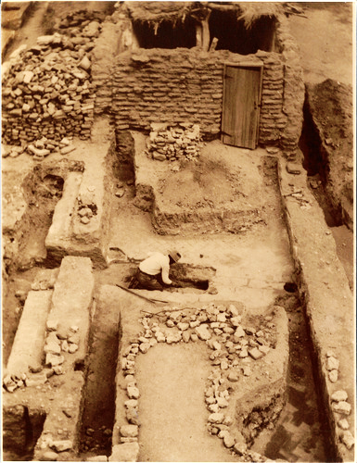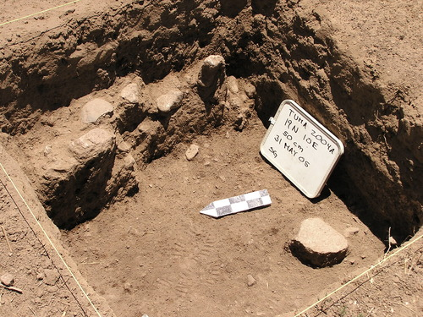
Tumacácori National Historical Park, 1935 (left) and 2005 (right) excavations. National Park Service.
Archeology is the study of material culture, such as objects and buildings, to know how people of the past lived. Archeologists divide their time between excavating historic sites, analyzing artifacts in the laboratory, and writing interpretations of their finds. Excavations require long hours spent outdoors performing manual labor. Because of this fact, archeology was traditionally viewed as a “men’s field” and unsuitable for “delicate” women.
Around 1900, women started to “crash the gates” of archeology. At that time, many excavations were carried out in cooperation with the National Park Service. Hearing that “the best way to get into the Park Service is to marry a Ranger,” several of the early NPS women did just that and labored alongside their husbands to preserve park resources as Rangers and archeologists. Some women, like Sallie Pierce Brewer, were referred to as “Honorary Custodians Without Pay.” This meant that even though they and their husbands performed the same work, the wives were not considered NPS employees and did not receive a salary. These women and other early female archeologists helped preserve thousands of archeological resources. However, their work often became overshadowed by that of their well-known husbands. As paid employees, these men were often the ones who led the excavations and whose names were atop the published reports. These factors meant that they, rather than their wives, became the public face of the excavations.

Ann Axtell Morris
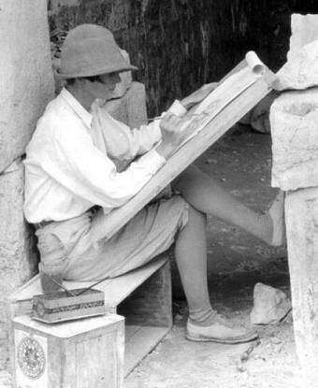
Ann Axtell Morris painting at an archeological site. National Park Service.
Ann Axtell Morris (1900-1945) was one of these early female archeologists. From the time she was six years old, Ann knew that she wanted to study ancient cultures. It was not until much later that she quite understood what archeology was. In her words, “If there was an “ology” that told the story [of the past], and if there were “ologists” who knew anything about it, my course lay clear.”
Ann studied at Smith College in Massachusetts. After graduating, she traveled to Paris to attend the American School of Prehistoric Research. In 1923, she married Earl Haltstead Morris. Though Ann was an archeologist in her own right, she referred to her “career of being an archeologist’s wife.” Like the “Honorary Custodians” in the national parks, she worked alongside her husband while he led excavations. Together, she and Earl wrote many studies on ancient lifeways within the American Southwest and Mexico, including one on Native American sandals that their archeologist daughter Elizabeth Ann expanded upon years later. Ann herself wrote two popular books, Digging in the Southwest and Digging in the Yucatan, which educated members of the public about archeology and included some of her best stories from the field.
From the time they were married to 1933, the Morrises lived where they excavated either in tents or small houses. They worked on multiple sites during this time including Mesa Verde in Colorado and Aztec Ruins in New Mexico. These sites had been designated national parks in 1906 and 1923 respectively. Starting in 1924, in cooperation with the Carnegie Institute of Washington, the Morrises spent five winters excavating the Mayan city Chichen Itza in eastern Mexico. From 1923 to 1929 and again in 1932 they excavated Canyon del Muerto in Canyon de Chelly, Arizona. While there, they documented ancient mummies, artifacts, architecture, and art. In 1931, partly because of their work, Canyon de Chelly was made a national monument. Together with Mesa Verde and Aztec Ruins, the site and the ancient material culture within it was now given federal protection.

Ann’s Methods: Photographs and Paintings

Archeology is often a destructive science; once a site is excavated, it cannot be put back the way it was before the trowels and shovels disturb the ground. Recording finds and their context becomes crucial and is what defines archeology as a science. Archeology is not indiscriminately pulling interesting artifacts out of the ground for display. Rather, archeologists spend hours interpreting not only what an object is but its context as well. This includes where on the site it was found, how deeply it was buried, what other artifacts or features were next to it, and what the ground around it looked like. As Ann Axtell Morris explains: “Digging, properly done, will yield a good 99 percent more information than a shovel in the hands of an unthinking person bent only on treasure-seeking… an object is only an object, no matter how old or beautiful or extraordinary it might be. But an object with a story is straightaway enhanced a thousandfold.”
Illustration is one tool archeologists can use to record how artifacts and sites appear. It ranges from simple pencil sketches to high-definition, computer-generated models. Archeologists use different types of illustration for different tasks. Field notebooks, daily diaries kept during excavations, may include quick sketches of artifacts and features as they are being uncovered. Aerial photographs are capable of capturing entire sites to better understand how features are spatially related. Black-and-white images are best for showing small details while color photographs are useful when comparing decorative styles.
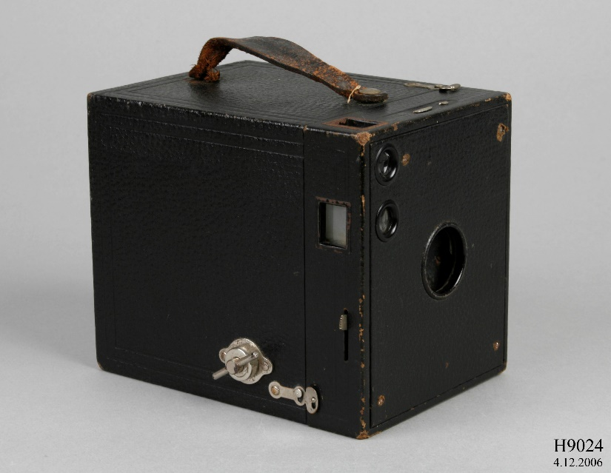
Kodak Brownie Camera Model B made between 1908 and 1934. Museum of Applied Arts and Sciences.
Ann was working at a time when cameras were just a few decades old. In 1888, George Eastman created the Kodak camera that used celluloid film instead of glass plates to record images. Twelve years later, he began selling “Brownie” cameras for $1 each. Compared to the equipment that came before them, these mass-produced cameras were small and easily carried, allowing any member of the public to try their hand at photography. Ann and Earl used these early cameras on site to document their finds.
However, in her book Digging in the Southwest, Ann recounted:
“Photography [was] awfully difficult. The pits were narrow with crooked approaches, hence not only was the lighting bad, but a good camera set-up was almost impossible to obtain. The tripods had to be balanced at a precarious straddle, and Kodak necks were bent till it looked as if they were peering between their own legs.” (Ann Axtell Morris, Digging in the Southwest, 217.)
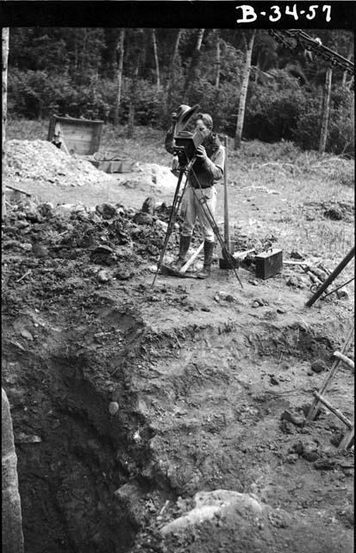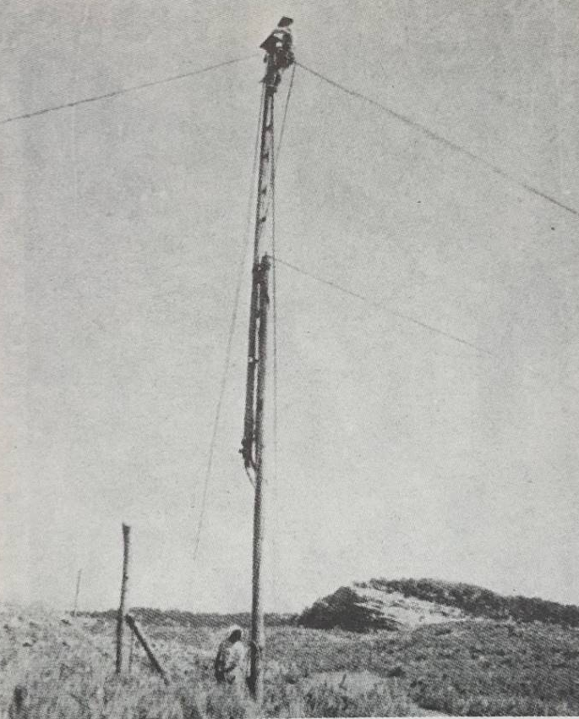
Left: “Mr. Earl Morris photographing.” Harvard Peabody Museum of Archeology and Ethnology. Catalog Number 58-34-20/29244. Right: “Lengthening the Camera Tripod.” Ann Axtell Morris, Digging in the Southwest, 116.

In addition, their cameras only produced black-and-white images. Color photography would not be fully developed until the 1930’s, ten years into the Morris’s excavations. While the images could capture fine details, they did not display the fantastic “red, yellow, black, white and green pigment” present upon the walls.
Ann therefore turned to another medium: painting. Her skill as an artist allowed her to preserve how finds appeared in situ (“in place”) without having to worry about lighting conditions or camera angles in limited space. She focused on petroglyphs, pictographs and murals, first tracing images in black then filling in the colors with her brushes.
While at Canyon del Muerto in Canyon de Chelly, she created watercolors of the paintings on cave and kiva walls. Her goal was to “copy in full color and accurate detail as many of the hundreds of pictographs along the canyon’s gallery walls as possible.” In 1929, she illustrated the ancient art at other Canyon de Chelly sites including Antelope House, Pictograph Cave, and Standing Cow Ruins. These paintings would eventually be exhibited at the American Museum. In 1924, Ann began painting the Temple of the Warrior murals at Chichen Itza. This work lasted for the next four seasons. Her final illustrations were published in a co-authored work with Earl and artist Jean Charlot.
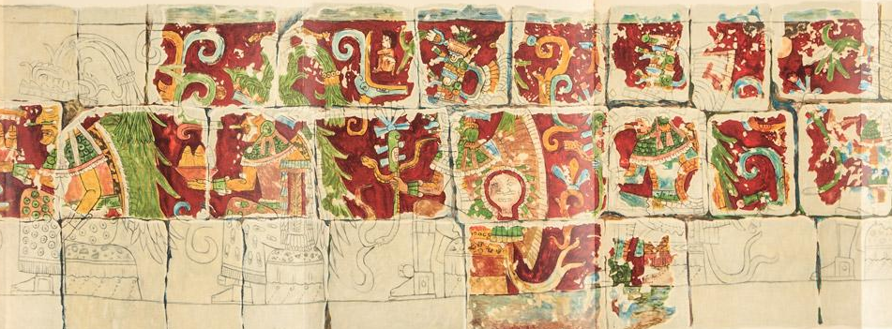
The Temple of the Warriors at Chichen Itzá, Yucatan. Earl H. Morris, Ann Axtell Morris, and Jean Charlot. Carnegie Institution of Washington publication no. 406, May 21st, 1931.
Ann’s work was important for multiple reasons. She not only captured the painted figures’ forms but also their original coloring. Scholars could use this information to answer many questions, including what kinds of paint ancient peoples used and what colors carried symbolic meaning. Like her photography, Ann’s watercolors also aided in preserving the pictographs; while the images in the rock themselves may eventually fade or erode, her illustrations would remain.

Activity: Archeological Illustration

Step 1) Like Ann, archeologists today often include photographs and illustrations in their reports. Using a pencil and a piece of scrap paper, how accurately can you can draw Object A and Object B?

Step 2) What elements of the objects are emphasized in these photographs? In your illustrations? How does having both a color picture and a simplified black and white drawing of an object help you to interpret it?

Step 3) Sometimes archeologists only color in half of an illustration. Use a ruler to draw a line down the center of your pot illustration. Using colored pencils color in only one side to match the original artifact’s decoration. How does having both versions of the artifact side-by-side help emphasize all of the object’s qualities?

Step 4) Find a partner and compare your illustrations. How similar are they? How do they differ? If you were both archeologists in the field drawing the same artifact, why might these similarities and differences matter?
What was the most challenging part of making these illustrations? After comparing and contrasting your work with your partner’s, is there anything that you would have done differently? How did your process differ from theirs?
You have now seen how long it takes to illustrate an artifact. Even with modern high-tech cameras, archeologists still take the time to draw what they find on a site. Discuss with your partner why you think this is.

Object A: Ceramic pot from Tonto National Monument. National Park Service.

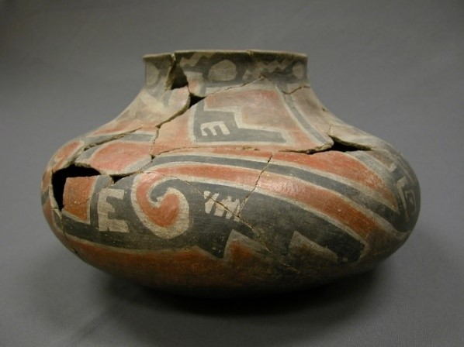

Object B: McKee Springs Petroglyphs, Dinosaur National Monument. National Park Service.

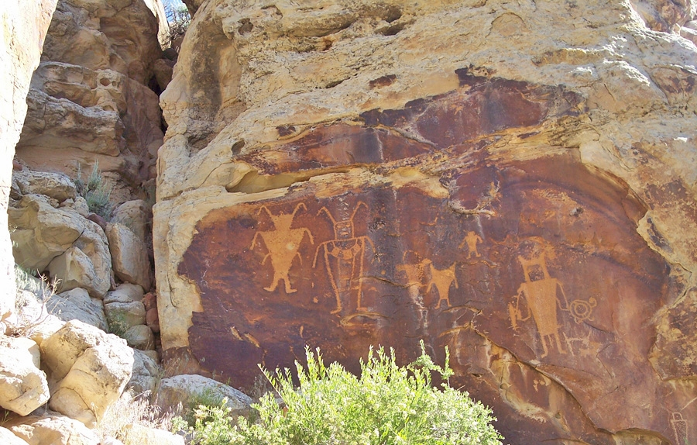

Mandelson, Dayle A. “Women’s Changing Labor-Force Participation in the United States,” in Women and Work: A Handbook, eds. Paula J Dubeck and Kathryn Borman, 6.
Mandelson, Dayle, “Women’s Changing Labor-Force Participation,” 6.
Martelle Trager, as quoted in Kaufman, Polly Welts, Natural Parks and the Women’s Voice: A History, University of New Mexico Press, 1996, 87.
Ruth Ashton Nelson, as quoted in Natural Parks and the Women’s Voice: A History, 87.
Kaufman, Women’s Voice, 86.
Morris, Ann Axtell. Digging in the Southwest, Peregrine Smith, Inc., 1978, 13.
Morris, Digging in the Southwest, 16.
Hays-Gilpin, Kelley, Ann Cordy Deegan, and Elizabeth Ann Morris. “Prehistoric Sandals from Northeastern Arizona: The Earl H. Morris and Ann Axtell Morris Research.” University of Arizona Press, 1998. URL: http://www.worldcat.org/title/prehistoric-sandals-from-northeastern-arizona-the-earl-h-morris-and-ann-axtell-morris-research/oclc/37567213/viewport.
Lister, Florence C. and Robert H. Earl Morris and Southwestern Archeology, University of New Mexico Press, 1968, 143.
Morris, Ann Axtell. Digging in the Southwest, 92.
Lister, Florence C. and Robert H., Earl Morris, 163.
Lister, Florence C. and Robert H., Earl Morris, 137.
Grant, Campbell, Canyon de Chelly: Its People and Rock Art, University of Arizona Press, 1979, 143.

